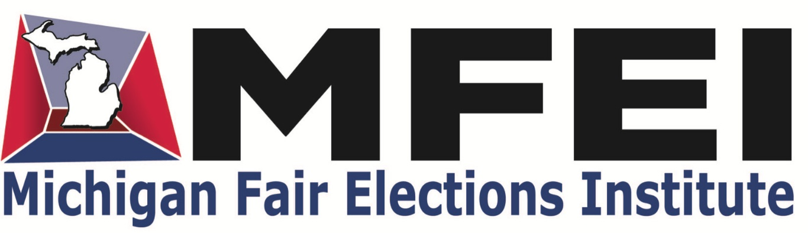

FOR IMMEDIATE RELEASE
December 3, 2025
Contact: Melanie Nivelt
Melanierepresents@gmail.com
248.425.8896

New Poll: MI Local Clerks Join County Clerks in Opposing Ranked Choice Voting

STOCKBRIDGE, Mich. — In a revealing straw poll released today, 79% of responding Michigan local election clerks oppose or strongly oppose implementing Ranked Choice Voting (RCV), highlighting profound concerns over costs, training, and administrative overload. The survey by the Michigan Fair Elections Institute comes as RCV advocates collect signatures for a November 2026 ballot initiative to amend the state constitution in favor of the novel voting method.

Local clerks — the 1,533 municipal, township, and village officials who administer elections in Michigan's communities, distinct from the 83 county clerks—operate on limited budgets in small towns and cities. They manage voter rolls, polling locations, and tabulations amid rising demands from 2022's Proposition 2 expansions. The non-partisan survey, sent to all local clerks October 16-20, 2025, garnered 239 responses (16%), with 51% adding open-ended comments in the qualitative section.

Findings show 90% expect extensive voter education will be needed, 85% anticipate major poll worker training, and 69% see audits as "very difficult." Just 6% predict increased turnout; 41% foresee a decrease.

The qualitative responses, detailed in a table of clerk comments, reveal raw practicality concerns over politics. One anonymous clerk wrote: "As a smaller municipality, I fear the costs of conducting an election will skyrocket . . . The reeducation costs will be tremendous . . . Where will the funding come from?" Another clerk added: "Elections have become labor intensive for clerks. There is no more room on our plates." Clerk support for RCV was rare, but one noted: I believe ranked-choice voting would significantly benefit voters and strengthen our democratic process.”
"These clerks are the unsung heroes of democracy, yet RCV threatens to overwhelm them," said Darlene Hennessey, survey coordinator. The results align with the Michigan Association of County Clerks' October opposition.”

Michigan Fair Elections Institute is a non-partisan, nonprofit organization that supports election integrity. It provides resources to clerks for maintaining accurate voter rolls and recognizes outstanding clerks through its annual and achievement-specific Sunlight Awards.

Find the full survey report HERE. For interviews, contact Melanie Nivelt at 248.425.8896 or melanierepresents@gmail.com.

###

